Unit 1 Can you play the guitar?
Practice 1

作业导航
1.掌握本单元的基础知识：情态动词can在一般疑问句、what问句和简略回答中的用法及其否定形式。
2.能够通过练习熟练掌握对自我才艺的表达。
一、根据本单元所学词汇，补全下列单词
g _t_r d_nc_ ch_ss
p_ _nt sp_ _k p_ _n_ sw_m_ _r
ch_ldr_n k_d s_ _mer
c_ _p dr_m tr_mp_t
vi_l_n m_s_c_an m_ _be
t_lk
二、按图写单词
A___________B___________C___________D___________
E___________F___________G___________H___________
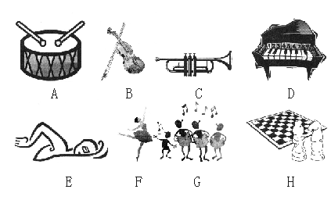
三、选词填空（根据需要改变单词大小写）
paint，sing，where，table，guitar，join，volleyball，name，can，what，club
1.Ren Lijuan wants to join a___________.
2.Rick likes sports.He plays___________.
3.___________ you play the piano?
4.Bai Jie can dance and ___________.
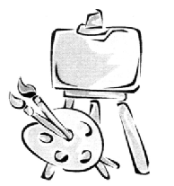
5.___________ club do you want to join?
6.___________ are your shorts? They are on my bed.
7.I want to join the art club.Oh, can you ___________?
四、连词组句 (请注意大小写和标点符号)
1.want, join, the, club, to, music, I
___________________________________
2.no, you, I, play, the, can, guitar, can't
___________________________________
3.club, you, do, want,join, to, what
___________________________________
4.to, want, the, join, we, English club
___________________________________
5.computers, the, help, summer camp, needs, with
___________________________________
五、看图,完成下列对话
1.A:I want to join the music club.
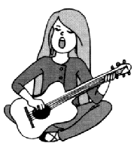
B:Can you ___________ ___________ ___________?
A:Yes, ___________ ___________.
B:Can you ___________ ___________ well?
A:___________, ___________ can’t.But I can sing very well.
2.Zhen Zhuo:I want ___________ join ___________ ___________ club.
Mr.Black:Can you ___________ ___________ drum?
Zhen Zhuo:No, ___________ ___________.
Mr.Black:___________ ___________ play ___________ trumpet?
Zhen Zhuo:___________, ___________ can't.
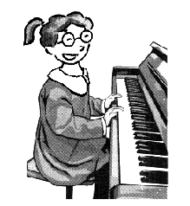
Mr.Black:Can you play the guitar?
Zhen Zhuo:Sorry, I can't play ___________ ___________, either.
Mr.Black:___________ ___________ ___________ do?
Zhen Zhuo:I can play ___________ ___________ very well.
Mr.Black:OK.Let me see.Mm…That's good.You can join the music club.
Zhen Zhuo:___________ ___________ very much.
3.Lei Hao:I want to join ___________ ___________ club.
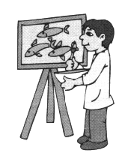
Miss Fang:What ___________ ___________ ___________?
Lei Hao:I can paint pictures.
Miss Fang:___________ ___________paint horses?
Lei Hao:No, ___________ ___________.
Miss Fang:___________ ___________ you paint?
Lei Hao:I can paint fish very well.
参考答案
一、guitar, dance, chess, paint, speak, piano, swimmer, children, kid, summer, camp, drum, trumpet, violin, musician, maybe, talk
二、A.drum B.violin C.trumpet D.piano E.swim F.dance G.sing H.chess
三、1.club 2.volleyball 3.Can 4.sing 5.What 6.Where 7.paint
四、1.I want to join the music club.
2.Can you play the guitar?No, I can’t.
3.What club do you want to join?
4.We want to join the English club.
5.The summer camp needs help with computers.
五、1.B:play the guitar A:I can B:play it A:No, I
2.Zhen Zhuo:to, the music Mr.Black:play the Zhen Zhuo:I can't Mr.Black:Can you, the Zhen Zhuo:No, I Zhen Zhuo:the guitar Mr.Black:What can you Zhen Zhuo:the piano Zhen Zhuo:Thank you
3.Lei Hao:the art Miss Fang:can you do Miss Fang:Can you Lei Hao:I can't
Miss Fang:What can

